 |  | London School of Science
 |  | and Technology
 |  | Pearson BTEC Level 5 HND |  |  |  | MA
 |  | Diploma in Business |  |  |  | MA
 |  | Unit 5: Mangement Accounting |  |  |  | MA
 |  | Assignment Title: | Mangement Accounting |  |  | MA
 |  | Module Leader : | Mubashir Qureshi |  |  | MA
 |  | Internal Verifier: | Mohammad Haider |  |  | MA
 |  | Issued on: | 19th Feb 2018 |  |  | MA
 |  | Deadline: | 08th June 2018
 |  | Submitted on:
 | Student Name:
 | Student ID:
 | Campus: Alperton/Luton/Birmingham (delete as appropriate)
 | Pearson Registration Number:
 |  |  | Instructions & Learner Declaration
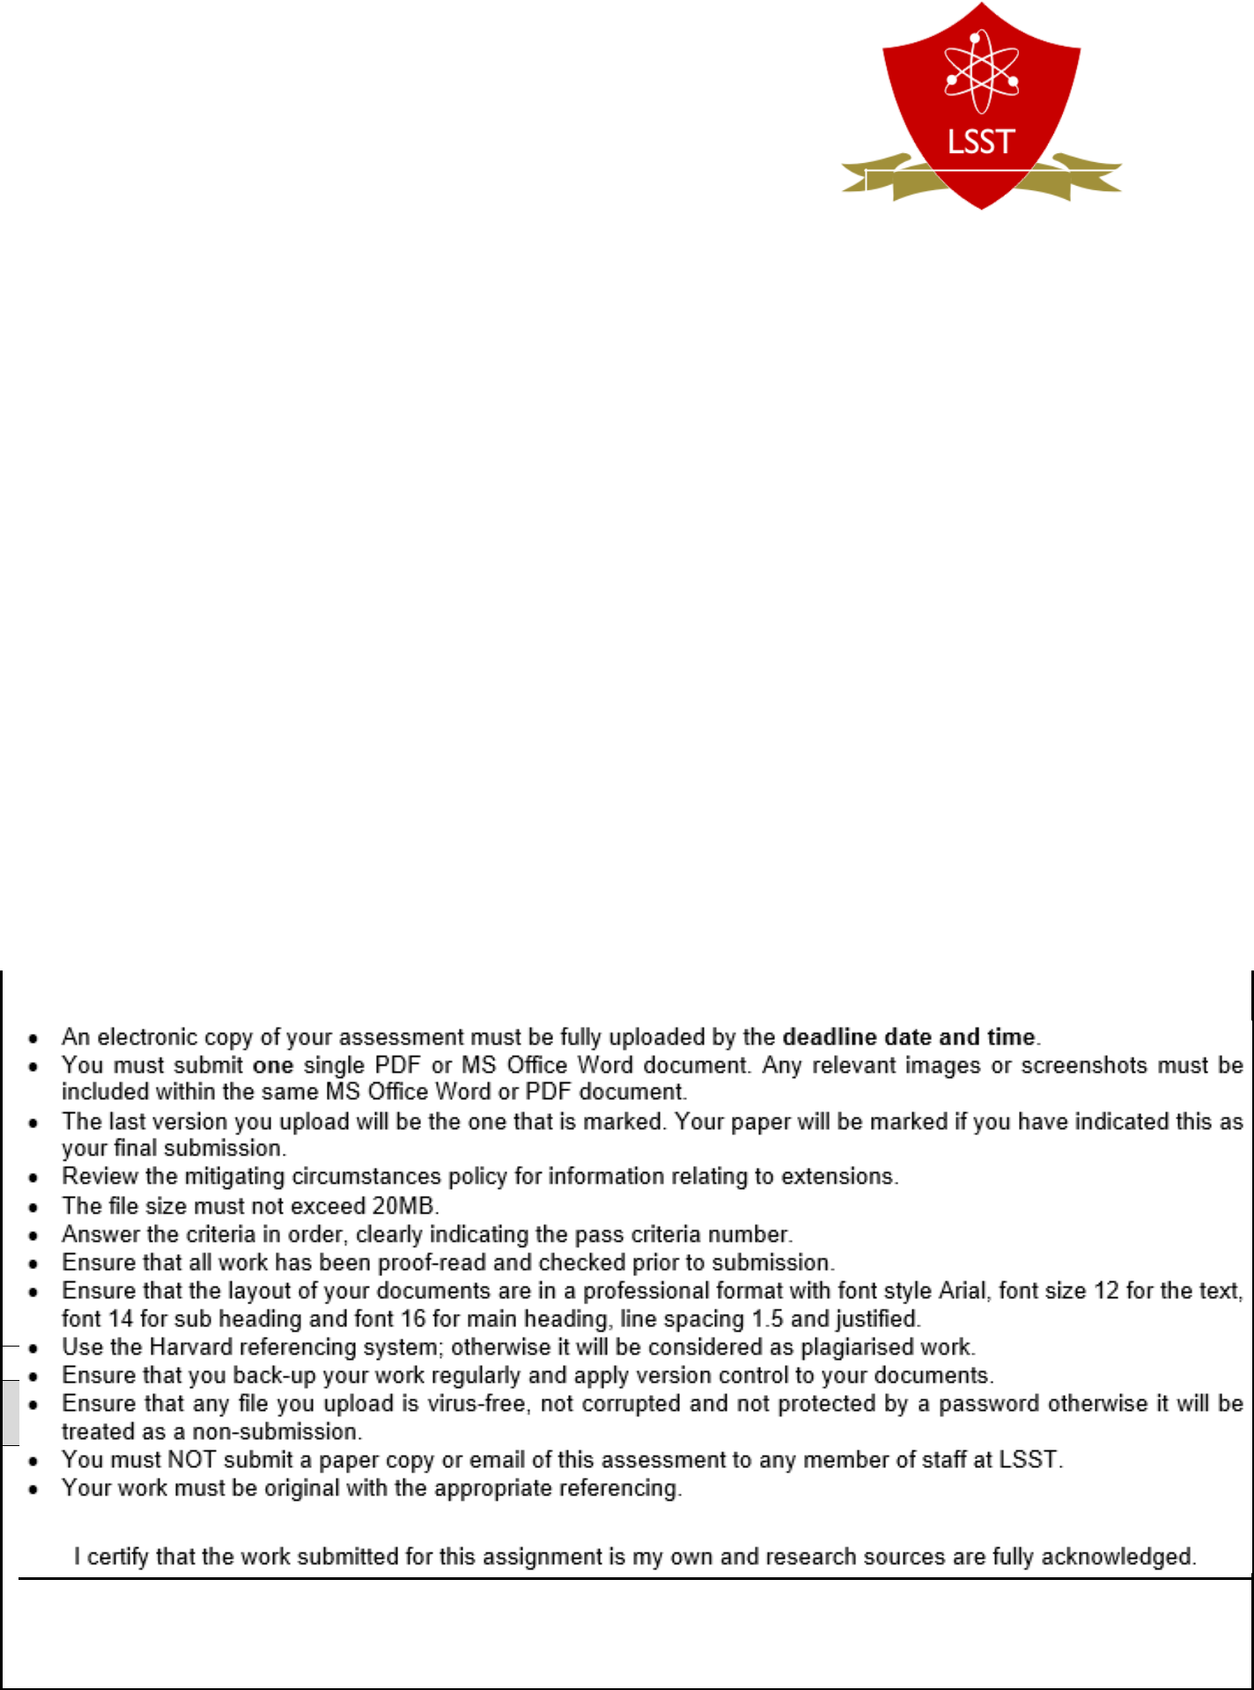

Vocational Scenario or
Context

Signature & Date:

Unit5: Management Accounting_February 2018

Introduction

Management accounting is prepared for the management of any company. It is important to control the cost and other activities of a company. It helps manager in different way. Here I show the importance of management accounting on the perspective of RYANAIR. RYANAIR is an airlines service provider. I also show the different types of management accounting system within RYANAIR. I have calculated the per unit cost according to the absorption costing method and marginal costing method and also described why there has a difference betIen the amount of both method. Then I have also shown the income statement under absorption costing method and marginal coasting method. I have also presented the advantages and disadvantages of different types of planning tools for budgetary control. I have solved a math regarding the cash flow of RYANAIR. At last I have shown the comparison betIen the RYANAIR and SouthIst airlines.

2

TASK-1

P1. Defining and explaining the Management Accounting and different types of Management Accounting

Date: 01-03-18

To: Line Manager, RYANAIR

From Management Accountant

Dear Sir,

With due respect, I am going to explain and define management accounting and different types of managerial accounting.

Management Accounting

Managerial Accounting is a process to provide information to the managers so that they can make a decision regarding the different segments of an organization (Olive, 2012). Managerial accounting is necessary for an organization because it helps the managers of an organization to make a plan. It generally emphasizes on the relevancy of the data rather than accurate and verifiable. For example, it is assumed that the price of raw materials will be loIr which is not a verifiable information. But the information has a relevancy, so it is a significant news for the manager. And it is managerial accounting from which manager come to know the information. Managerial accounting stores the information elaborately. It is very useful to the internal parties to find out any information from the statement of managerial accounting. Managerial accounting is made on the basis of segment. That’s why it is easy for the manager to make a decision and monitor the performance of a segment. Managers understand which segment needs to more focus. Managerial accounting helps a manager in planning, controlling and monitoring a project. At first manager draws a plan for a project by finding break even point, contribution margin, probable variable cost, fixed cost and net operating income. If the manager satisfy with the result only then he take the decision for implement of the plan (Christensen, Cottrell and Budd, 2016). Then he controls the facts which can be influenced by him. After a specific time, manager evaluate the performance of the actual data with the estimated data. It is not follow the rules and regulations of GAAP. Because it is not presented before the external parties. But sometimes the potential creditors want to check the statement of managerial accounting. Unlike financial accounting, it is not mandatory. So it can be said that managerial accounting plays a

3

important role in an organization. There has a difference betIen managerial accounting and financial accounting (Williams et al., 2018).

Differences betIen managerial accounting and financial accounting:

 | Managerial Accounting |  |  |  |  | Financial Accounting
 | Managerial accounting is a system which |  |  |  |  | Financial accounting is a process which depicts
 | presents the financial condition to internal |  |  |  |  | the financial position and performance to
 | parties. |  |  |  |  | external parties.
It is not prepared according to GAAP. |  |  |  |  |  | It is prepared according to GAAP.
 | It is made in details. |  |  |  |  | It is not made elaborately.
 | It is prepared segment wise. |  |  |  |  | It is prepared for the whole of company.
 | It serves the management of an business |  |  |  |  | It serves the external parties such as debt
 | organization. |  |  |  |  | holders, suppliers of an business organization.

It is not compulsory for a firm.

It is mandatory for any firm.

Different types of management accounting systems

There are four fundamental systems in management accounting. These are briefly described in the following:

- Cost Accounting System: Cost accounting system is also known as product costing system or costing systems (Olive, 2012). It helps the mangers to predict the cost of production of an organization. By doing cost accounting, the manager can analyze the profitability of RYANAIR. It also helps to control the cost of production of RYANAIR.

- Inventory Management System: Inventory is an important element of production. The success or failure of a business largely depends on the inventory management. Inventory management system helps the manager of RYANAIR by giving the information of warehouse, the amount of current orders by customers and the amount of receiving inventory from the suppliers. There are some software which is used to control the inventory

management system (Porter and Norton, 2017).

- Job Costing System: Under job costing system, a manager calculates the cost of a particular product or job. The manager needs to calculate three types of cost in this system. These are

4

direct labor, direct material and overhead cost. It helps the manager of RYANAIR to control

the cost segment wise (Christensen, Cottrell and Budd, 2016).

- Price Optimizing system: Price optimizing system is a process from which a manager come to know the different mixture of price and demand. It helps the manager to do the pricing of a product. It is important for the managers of RYANAIR so that they can do the pricing such a manner which covers the production cost of the product.


P2. Explaining the different methods used for management accounting reporting

Different management accounting reporting methods are described in the following:

There are different types of methods for management accounting reporting. These are cost report, budget report, performance report and other report. These are given below shortly:

Cost Report

By keeping of cost accounting report helps a manger to up to date about the company’s cost. If one manager fails to control the company’s cost properly, the performance of the company will be poor. From the cost accounting report the manger understand which segment needs to be more focused. They also know the reason of increasing cost of a particular segment or good. It is also necessary to intensify the profitability of the company (Olive, 2012). Because sometimes manager can not increase price, at that situation manager try to lessen the cost of the product. It also helps the managers by providing the information of variable cost, fixed cost and mixed in details (Porter and Norton, 2017).

Budget Report

Budget is a momentous part for a business. Budget is generally prepared for the future activities of business organization. According to budget manager makes the plan. The manager estimates all types of inflow and outflow of the organization. Then manager allocates the money according to budget. Similarly the manager of every segment or project makes a budget for their future activities. And the managers have a tendency to control their activities according to budget. A good budget is a guide line for a manager. Because a good budget considers all kinds of contingencies. It also helps to increase the sale.

Performance Report

The main purpose of performance report to present the financial performance of a product or segment. It generally makes after the end of year or month. It conveys the advantages and

5

disadvantages of the product. Performance report is prepared by comparing the actual scenario with estimated scenario (Weil, 2017). If there is any deviation, manager identifies the problems for what the deviation is occurred. The performance report also helps the manager to modify the process if there is any fault. It is a yardstick to evaluate the manager performance as Ill.

Other Report

The mangers can make different of report like order, business situation report for their convenient. Order report conveys the amount of order placing in a month, what amount of products sold from this order. It also present the demand picture of customer. And business situation or opportunities report shows the position of business in the market. It also helps the manager to understand the strategy of the competitors. Then the manger set the tactics to compete with the competitors. As a result the company can survive successfully among the competitors. This types report helps the management to monitor a particular segment.

There are also some methods to prepare these kind of report. These methods are shortly describe here:

Job costing

Under job costing method the company can identify the cost of a particular products or jobs. It helps manager to know the cost pattern of particular segment (Olive, 2012). Then the manager can effectively control the cost of that segment. It also helps the manager to estimate the cost of that products or segments which helps him to make a budget for the products or segment.

Batch Costing

A company can produce many types of products (KAPLAN PUBLISHING., 2017). Some of these products may be identical. Under the batchcosting approach I can easily monitor the cost of identical products. It is helpful for manager to understand what types of products are more costly. The advantage of this method is to compare the cost among the identical cost.

Contract costing

A business organization does different types of contract with different types of parties. The main purpose of these types of contract is to accelerate the performance of the organization. So , ther is some cost to make a contract with any parties. These types of cost are recognize in this method. As a result the manager can show the actual picture of the company (Scott, 2014).

6

TASK-2

P3. Calculating costs per unit under both absorption costing and marginal costing and explain why they differ.

Date: 01-03-18

To: Line Manager, RYANAIR

From Management Accountant
Dear Sir,

With due respect, I am explaining on the calculation of per unit cost and income statement under both absorption costing and marginal costing.

Absorption costing method

Absorption costing method is a method of costing where the per unit cost is calculated by dividing fixed cost by the number of produced goods and adding the variable cost (KAPLAN PUBLISHING., 2017). As in this method the total cost is divided by the number of produced goods, the per unit cost is varies from time to time. Because the amount of produced is not always same. The problem is that it can not presents the actual cost (Weil, 2017). As a result, the result of this method can be mislead the manager. The per unit cost of RYANAIR is shown in the following:
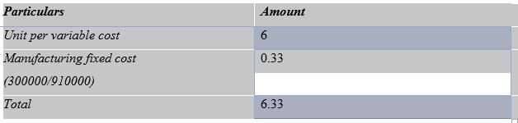

According to the question the fixed cost is 300000. And the number of produced goods is 910000 unit. So, I divide the fixed by produced goods.

Marginal costing method

Marginal costing method is a method costing where the per unit cost is calculated by summing up the variable cost (Scott, 2014). So the amount of per unit cost will be same whatever the amount of produced goods is. Although in this method the cost is remain same, it is not reflect the actual cost of
7

RYANAIR. But it has some advantages. It shows the efficiency of manager. It allocates the cost such a manner which is more useful than absorption costing method. The per unit cost of RYANAIR is given below:
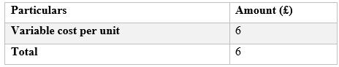

The per unit cost of RYANAIR is 6. Because in the marginal costing method, the per unit cost is calculated by variable cost (Porter and Norton, 2017). The reason of difference betIen the amount of absorption costing method and marginal costing method is that the absorption method includes fixed cost and variable cost but the marginal method includes only the variable cost (KAPLAN PUBLISHING., 2017).

8

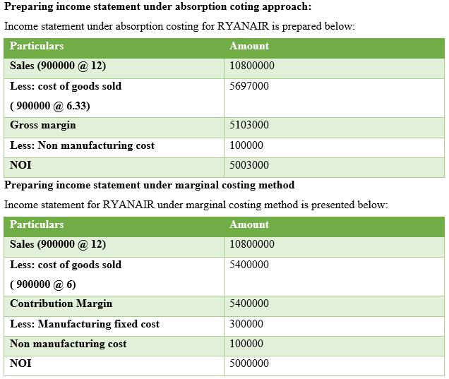

Task-3

P4. Explaining the advantages and disadvantages of different types of planning tools used for budgetary control

Date: 01-03-18

To: Line Manager, RYANAIR

From Management Accountant

Dear Sir,

In this task I am presenting the advantages and this disadvantages of different planning tools used for budgetary control.
9

Budget

Budget is a mirror of future activities of an organization (Management Accounting, 2010). It helps the manager to control the cost and other contingencies effectively. It directs the employees of an organization. In a good budget, the goal of the organization presents clearly. As a result the employees are clear about their responsibility. In the budget, the manager estimates the probable cost of a project. Therefore it is easy for the manager to compare the cost what is really incurred. Besides, budget is used as a guideline. At the end of year manager can easily evaluate the performance of the organization. The management of RYANAIR may make different types of budget to control the cost and intensify the performance of the company. There are four types of budget in the management accounting. Here I have discussed the advantages and disadvantages of these types which are used for the budgetary control (Christensen, Cottrell and Budd, 2016).

Master Budget

Master budget is budget which presents the budget of whole company for a fiscal year. According to the master budget, the manager of each department make their departmental budget. This types of budget is generally prepared by the top management of RYANAIR. It also reflects the long term goal of the company Financial management. (2014). London: BPP Learning Media.

It has some advantages. These are the transparent goal of company, the guideline for the employees and used as a benchmark.

It has also some disadvantages. It is not considered the efficiency of single department. As it is prepared on the estimation of cost, there have a possibility to be wrong of the estimation. Sometimes it create conflict betIen the interest of some departments (Correia et al., 2015).

Operational Budget

Operational budget is prepared based on the revenues and the expenses of a company. In this budget, the management estimates the revenues and expenses. The management estimates the variable costs and fixed cost of the company (Management Accounting, 2010). Advantages:

By doing the operational budget, the management know the contribution margin, break even point and gross margin. The management controls the variable cost and fixed cost effectively. Disadvantage:

10

The market can be changed any time which is not considered in the budget. The preferences of customer is totally ignored here. As a result the budget can not be proper guideline. The performance of employees have a great impact on the revenues of a company. But in this budget there has no evaluation method for employees.

Cash Flow Budget

The budget presents the estimation of future cash inflow and outflow of the company. In this budget, the management identify the potential source of cash outflows and inflows. Advantages:

It can be used for forecasting. The management can prepare for any kind of occurrence. The management can identify the sector from which cash inflows generates. They also know where large amount of cash are used (Britton and Waterston, 2013). Disadvantage:

The budget is prepared based on estimation which may not be accurate. Sometimes the budget can not consider some important factors which can affect the cash flow. It does not consider the inflation for which the management can able to understand the real scenario.

Capital Budget

Capital budget generally shows the source from where money receives and where the invests. Before investing any project, the management prepare a capital budget to know the profitability of the project. The management of RYANAIR also know the probable cash inflows of the project (Brigham and Ehrhardt, 2017). The company which has diversifiable business needs to make capital budget. Advantages:

As the cash inflows are known through capital budget, the management of RYANAIR can take a right investment decision. Capital budget considers the risk of new project, so it depicts an accurate result. It also considers the inflation rate (Management Accounting, 2010). Disadvantages:

11

Capital budget does not include any financial cost. There is a doubt regarding the accuracy of the result. It ignores some factors which are not measured by financially, but the factors have an influenced over the financial factors (Seal, Garrison and Noreen, 2015).

Standard costing

Standard costing is one kind of yardstick to compare the cost which is actually occurred. Standard costing helps a manager to lessen the cost of production. Standard costing also helps the manager to make a budget.

At the end of year, RYANAIR can compare its cost with the standard cost. If there has any difference betIen the actual cost and standard cost, the manager can easily detect the problem (Drury, 2017).

It has also some demerits. As the standard costing is fully based on estimation, the costing may be overstated or understated.
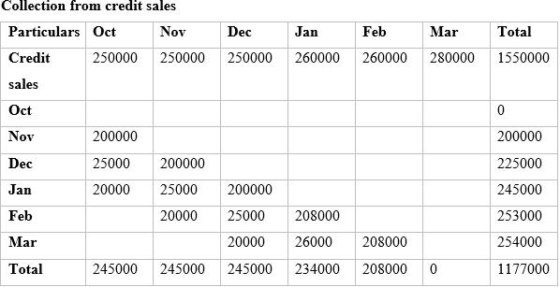

12

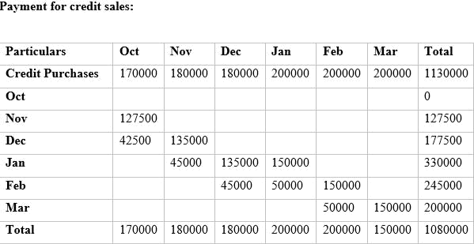

RYANAIR

Cash budget

For the 6 month ended in March

13

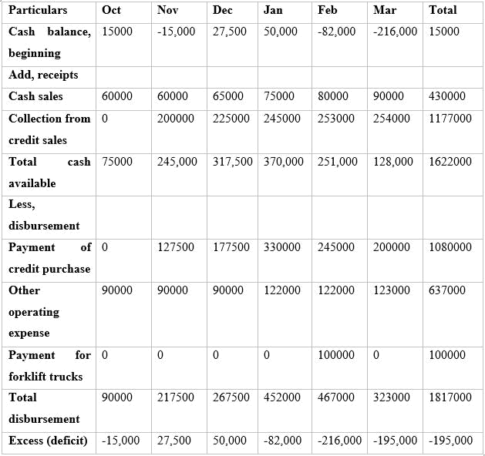

So. the there are deficit cash flow in RYANAIR.

14

Task-4

P5. Comparing RYANAIR with SouthIst Airlines in order to establish how organisations are adapting management accounting systems to respond to financial problems

Date: 01-03-18

To: Line Manager, RYANAIR

From Management Accountant
Dear Sir,

In this task, I have shown the comparison between RYANAIR and SouthIst Airlines.

Identifying financial problem, financial governance

RYANAIR:

RYANAIR is the one of the airline service provider which serves the passenger of Ireland and UK routes. It was founded in 1985. At the first of RYANAIR, it made more profit. But it faced a loss at the end of 1990.

To overcome the situation RYANAIR appointed new management team. The team set up the strategies to put down the problem.

Southwest Airlines:

Southwest airlines was founded in 1971. Primarily it was small air carrier from Houston to Dallas. But the CEO of Southwest airline properly understood that the company should be unique. So the CEO of Southwest airlines decided to assign skillful, customer oriented employees (BRIGHAM, 2018). It tries to provide different types of services to the customers so that the journey of the customer can be comfortable (Appannaiah, Reddy and Putty, 2010).

As a result it can make constant profit for 36 years. It can be said that the major reason behind the success of Southwest airline is right decision at right time.

RYANAIR faced a great economic disaster at 1990. It faced many difficulties because of the erosion of its profit. At that time, it diverged its five executives and made a loss of IR 20 million. To overcome this situation RYANAIR assigned a new management team. The management team made a strategy to control the cost of RYANAIR. They selected four types of cost which needed to be diminished. Their plan was to provide “low fare” services to their customers (Seal, Garrison and Noreen, 2015).

15

So they took many actions to low the operating cost. And the result was come at 2001. RYANAIR set it fare based on the demand and scheduled date. It could easily sell the ticket at minimum rate (Drury, 2017).

On the hand, Southwest airline tried to provide something different to the customers (Drury, 2017). It could make itself as a Ill-known brand. The most important thing is that it could take right decision at right time. Besides it trained it employees to deliver better service to its customers. And this strategy helped it to retain and attract the customers (Seal, Garrison and Noreen, 2015). It also gave low fare services to customers. That is why Southwest airline improved in its business (BRIGHAM, 2018).

Effective management Accounting Systems & Procedures

Effective accounting system means a system which records all financial activities in different reports such as cash manament flow, financial statement and cost report etc for a fiscal year. Many financial incidents are happened in a business around a whole year. The manager of a company must record such financial facts and use the information when it is necessary.

As a business ornaganization RYANAIR keeps a recording of its financial activities through different financial report. The management of RYANAIR get different types of information from this report such as per year profit, different types of cost, labor hours etc. This information helps them to set up a strategy for RYANAIR. By analyzing the information of financial report, the new management team who was assigned at that time found some factors for which RYANAIR faced a great loss. The factors were high operating costs, low services and high fare. To overcome this problem, the management took some steps. They tried to amplify the productivity of their employees, making contrat with different airport authories to serve passenger and controlling cost to reduce the ticket’s price. Their strategies were helped them to overcome the problem successfully. So, the present position of RYANAIR is the result of the management team strategies. It can be said that the management use the tools and techniques of managerial accounting system effectively.

Southwest airline is one of the renowed airline. It is a company which makes profit for 36 years consecutively. The top management of Southwest airline was expert and knowledgable to overcome any situation. The management team used the information effectively which got from management accounting system. They could forecast efficiently to meet the market. For this reason they gave their passenger low fare service. They also offered some additional services to make a comfortable journey

16

for the passenger. In this point the management team was more effective than RYANAIR. The reason behind the effectiveness of Southwest airline was proper management accounting system.

Conclusion

The biggest contribution behind the present position of RYANAIR is its management. RYANAIR’s management team handle every proficiently. To intensify their proficiency, they used the tools and techniques of managerial accounting. Managerial accounting helps them to make any kind of decision (Appannaiah, Reddy and Putty, 2010). It also helps the manager to present budget and control the cost. It helps them to understand the position of company properly. The manager can easily monitor the activities of the company. As the manager made the budget earlier, then he could use the budget as a guideline. If there had any deviation , the manager detected the problem promptly (BRIGHAM, 2018). So the problems which are faced by RYANAIR Ire solved by the management accounting. It can be said that managerial accounting is helpful to the management of any company.

17

References

Drury, C. (2017). Management and Cost Accounting Student Manual. Cengage Learning.

KAPLAN PUBLISHING. (2017). MANAGEMENT ACCOUNTING. [S.l.]: KAPLAN PUBLISHING.

Management Accounting. (2010). Pearson Education Ltd.

Olive, C. (2012). Accounting Management. Delhi: University Publications.

Seal, W., Garrison, R. and Noreen, E. (2015). Management accounting. London: McGraw-Hill Higher Education.

BRIGHAM, E. (2018). FUNDAMENTALS OF FINANCIAL MANAGEMENT. [S.l.]: SOUTH-

WESTERN.

Brigham, E. and Ehrhardt, M. (2017). Financial management. Boston (MA): Cengage Learning.

Correia, C., Flynn, D., Uliana, E., Wormald, M. and Dillon, J. (2015). Financial management.

Lansdowne: Juta.

Financial management. (2014). London: BPP Learning Media.

Appannaiah, H., Reddy, P. and Putty, R. (2010). Financial accounting. Mumbai [India]: Himalaya Pub. House.

Britton, A. and Waterston, C. (2013). Financial accounting. Harlow: Financial Times Prentice Hall.

Christensen, T., Cottrell, D. and Budd, C. (2016). Advanced financial accounting. New York, NY:

McGraw-Hill/Irwin.

Porter, G. and Norton, C. (2017). Financial accounting. Boston, MA: Cengage Learning.

Scott, W. (2014). Financial accounting theory. Toronto: Pearson.

Weil, R. (2017). Financial accounting. [Place of publication not identified]: Cengage Learning.

Williams, J., Haka, S., Bettner, M. and Carcello, J. (2018). Financial accounting. New York, NY:

McGraw-Hill Education.

18

19

